**Image processing HW 3**

**Names:**

**Raneem Ibraheem, 212920896**

**Selan Abu Saleh, 212111439**

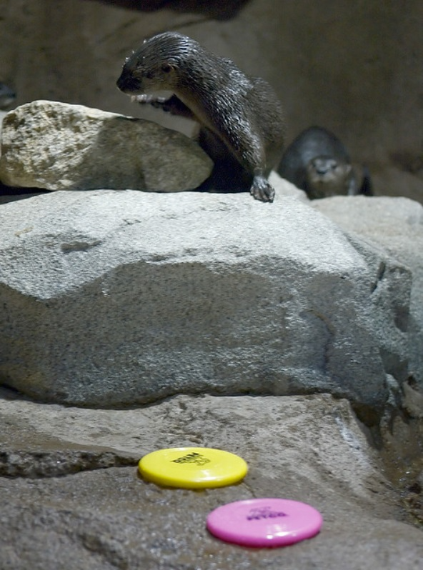**Question 1:**

**Original Image:**

**Nothing fancy to see here,**

**Just wanted to include it. 😊**

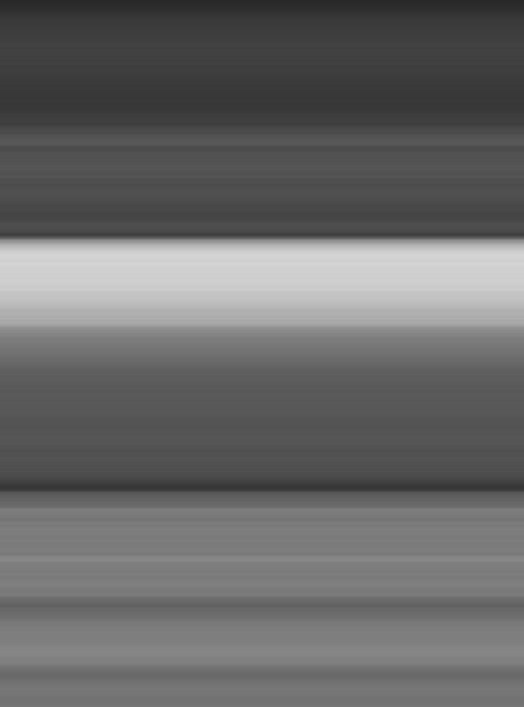**Image 1:**

**The image appears to have gone a**

**Spatial blurring or smoothing operation**

**And we can tell by the loss of details**

**And the significant reduction in intensity.**

**The operation seems to be applied vertically as the image appears to have vertical lines which is a result of a vertical**

**Operation, could be an averaging operation since all the pixels that has the same y value have the same color.**

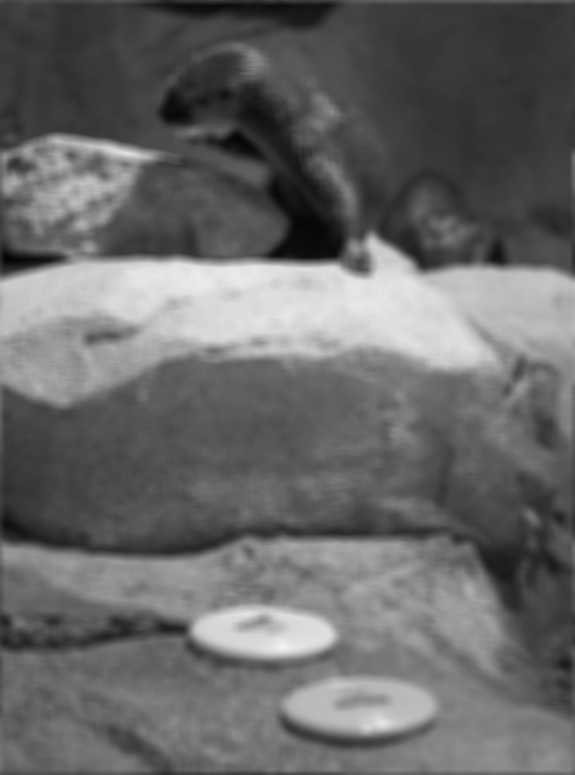**Image 2:**

**This image seems to have undergone a**

**Gaussian blurring, and we can tell by the smooth transitions and the loss of details in the image.**

**The operation appears to be done on both axes, because the blurring seems to be applied uniformly and not towards a specific direction.**

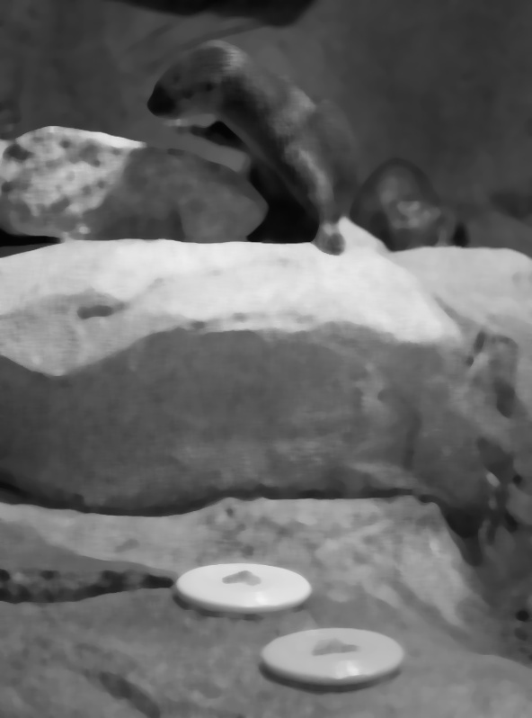**Image 3:**

**This image seems to have gone a bilateral filter operation and we can see that in the edge preserving, similar to the onion picture from the lecture’s pdf.**

**The operation is applied uniformly across both access since there is no bias towards any direction.**

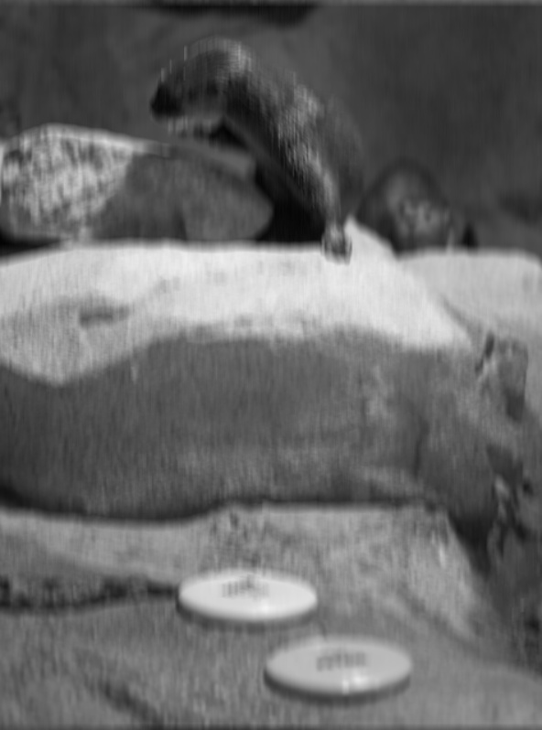**Image 4:**

**this image appear to have undergone a gaussian blurring as well, but the blurring seems to be more intense than image 2, which could be related to the std value.**

**The operation has been applied uniformly since we see no bias towards any direction.**

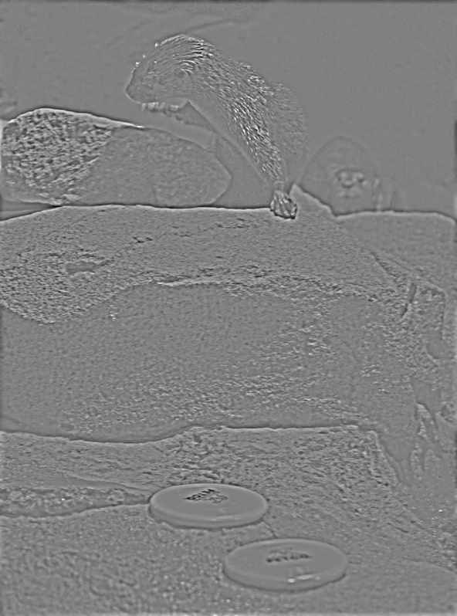**Image 5:**

**The original image went under a blurring mask and produced a blurred image, then the blurred image subtracted from the original image which produced the following image, that contains the details of the original image, and the axes was uniform.**

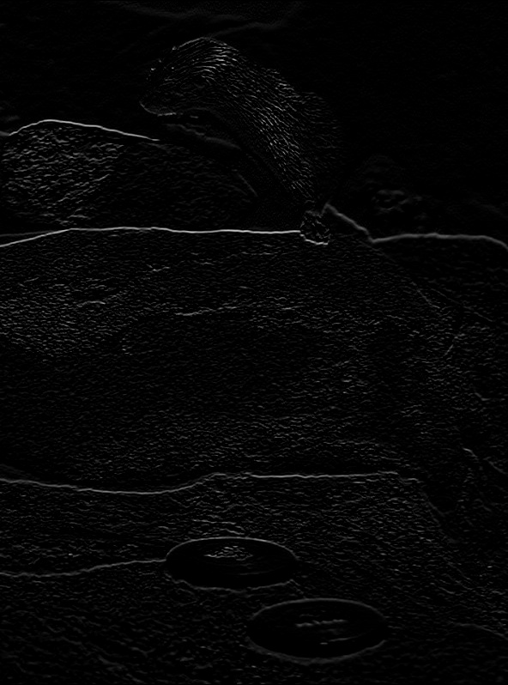**Image 6:**

**The image underwent a high pass filter, which we could see in the bright details that were higher than the chosen threshold, and everything that was under the threshold turned to black. The filter was applied on both axes.**

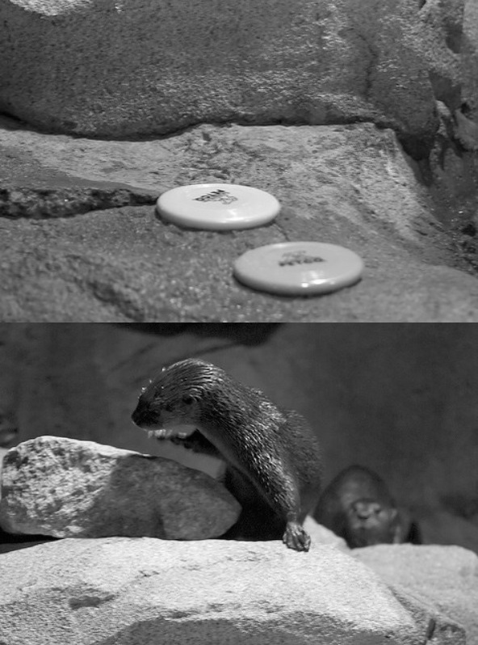**Image 7:**

**This image is obviously the same image from before but the top half and the bottom half were rearranged, this operation was done vertically, the split was horizontal but the swapping was vertical. It could be done in the following way, split the image in the middle, and change each pixel from the top half with the pixel in the same position in the bottom half.**

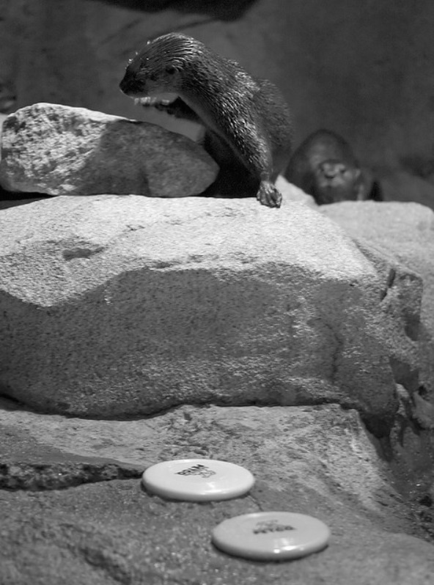**Image 8:**

**This is the grayscaled image of the original image, I don’t see any applied filters or spatial operations done to it. Cheers to you if you see any.**

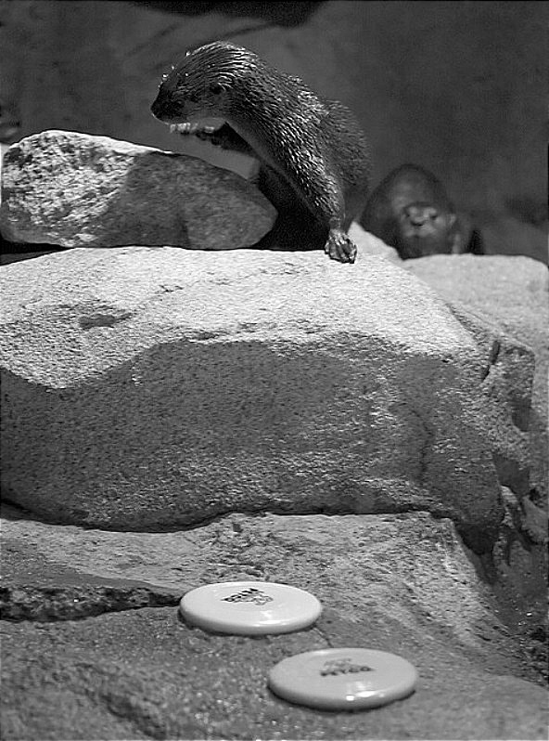**Image 9:**

**We can see in the fine details of the image that it has gone through sharpening and we can see the enhancements in the edges where there is a high frequency.**

**The operation was done uniformly on both axes.**

**Question 2:**

**Section A:**

**To implement the function, first let’s follow the homework implementation ideas, so we start by converting the image to a float type, we can see that in the code snippet beneath.**

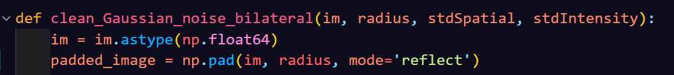

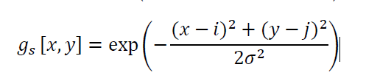**Then we want to compute the formula:**

**So what we do is create the gaussian kernel based on the spatial distances with the following code snippet:**

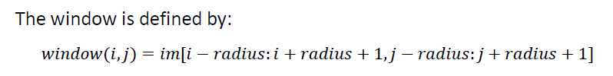**now we want to go over all the pixels to do the computations, so we iterate with 2 nested loops then we want to extract the window size around the current pixel, which is shown in this formula:**

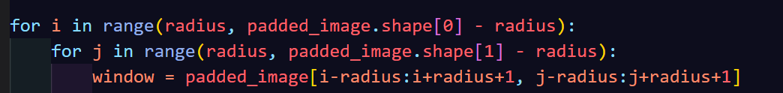**and the implementation is done in the following code snippet:**

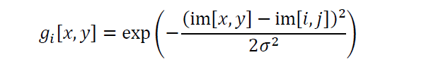**now we want to compute the gaussian mask based on intensity shown in the formula:**

**then we want to combine the weights we got for future calculations, and we do that in the following lines:**

**Now we want to apply the bilateral filter by following the formula:**

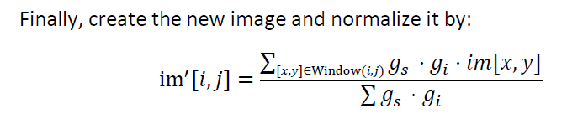**and we do that with the following lines:**

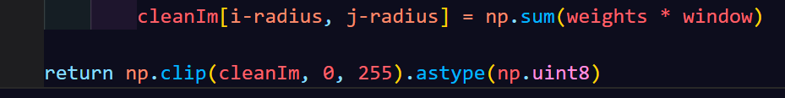

**Then we return the result and ensure it is a valid gray scale image.**

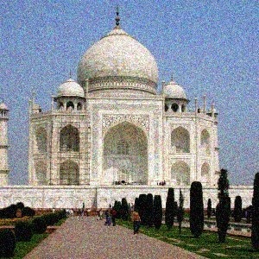**Section B:**

**First let’s start with the taj mahal image, here is the original image:**

**It is evident that the image has some sort of gaussian noise, which we can fix with a bilateral filter and could be solved with a moderate stdSpatial, as well as intensity, hence the choice of the parameters.**

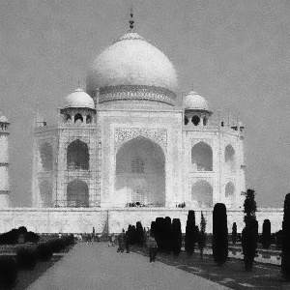**Here is the fixed gray scale image:**

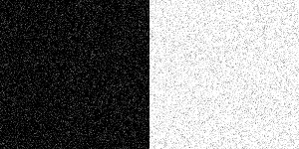**Now for image 2 which is the NoisyGrayScale image, we could see an extreme salt and pepper noise, which a bilateral filter might not work well on it, and while it could reduce the noise, yet other filters could perform better such as the median filter. Here is the original image:**

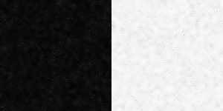**And here is the fixed image:**

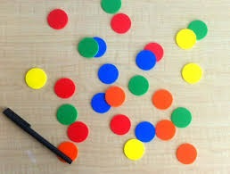**As for image 3 which is the balls image, the image seems to have artifacts that the bilateral filter could smoothen without blurring the image too much, higher spatial and intensity parameters might help. Here is the original image:**

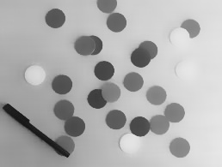**And here is the fixed gray scale image:**

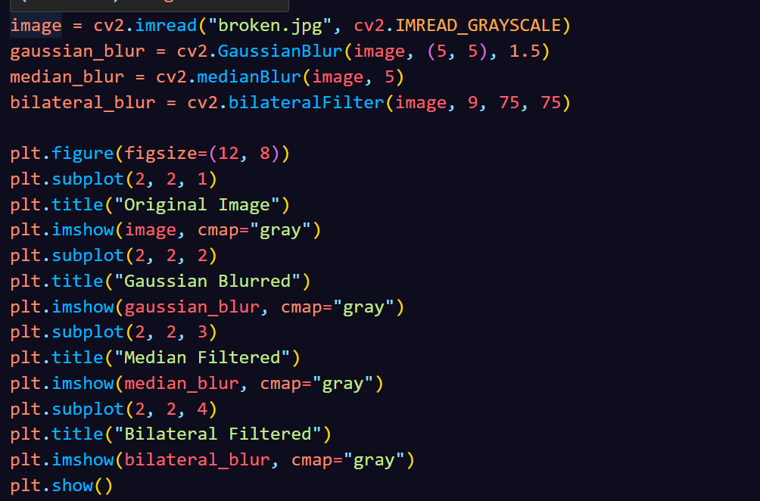

**Question 3:**

**Section A:**

**In this section we tried to fix the noised image using the image itself, so we tried different methods, such as median, gaussian, and bilateral filtering, which could be seen in the following code snippet:**

**And from looking at the pictures we found out that the median filter performed better in denoising the image (or at least that’s how it looked to our eyes). We chose the kernel size to be 5 because it preserved fine details and introduced smoothing, other kernel sizes could have either smoothened the image more if they were greater than 5, and they could have not removed as much noise if they were less than 5.**

**Here are the images, the before and after:**

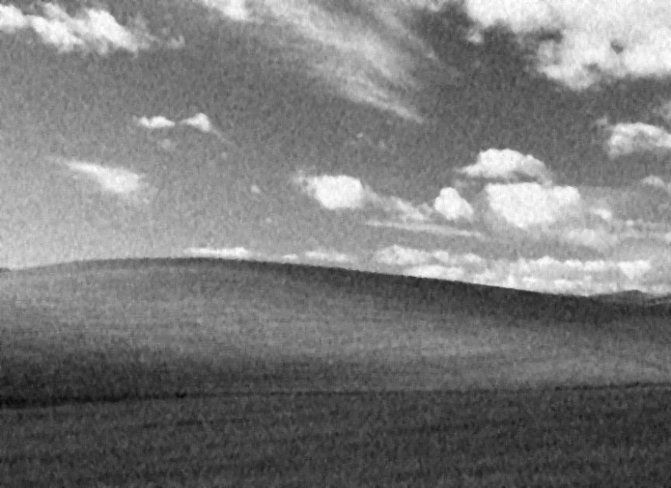**Before: After:**

**Section B:**

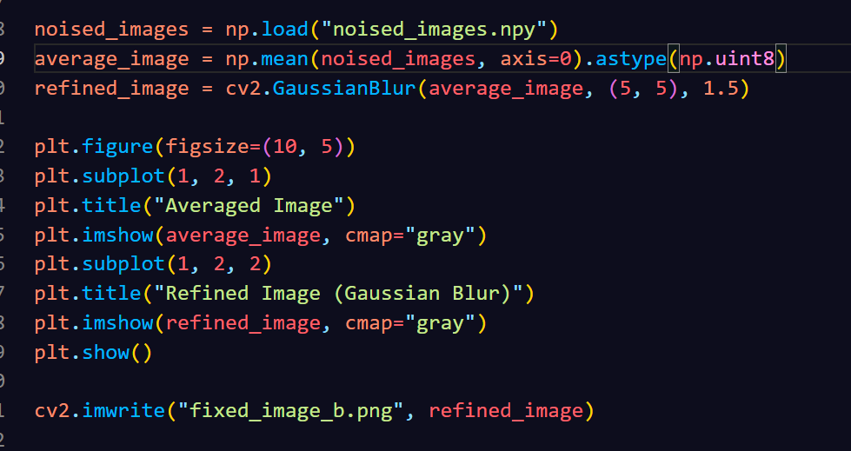**In this section we had the npy file that has 100 noised images, so we used those images to create a clearer image, and we did that by taking the mean of the pixels and then applied a gaussian filter on it to refine the image, and we can see that in the following code snippet:**

**We can see in the following image the results of the fix:**

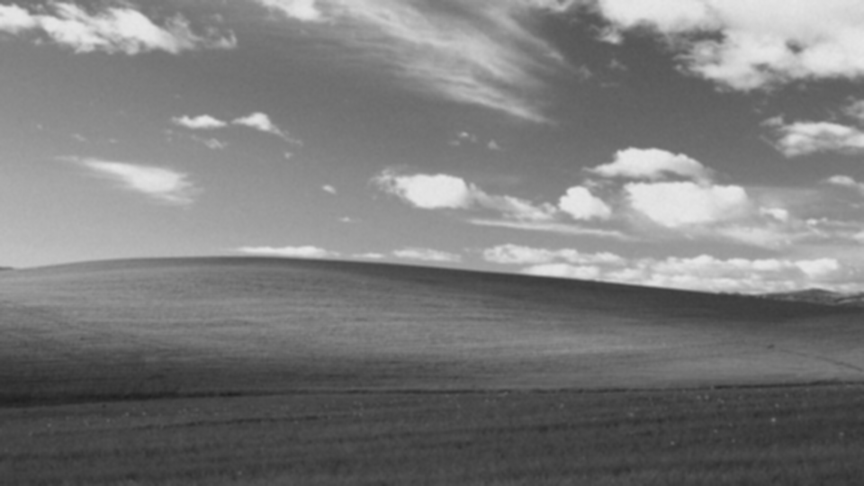**the image looks much clearer than the images that were produced in section A, because we took many inputs and that was effective for noise reduction. The parameters choice in here was similar to before, for the same reasons.**